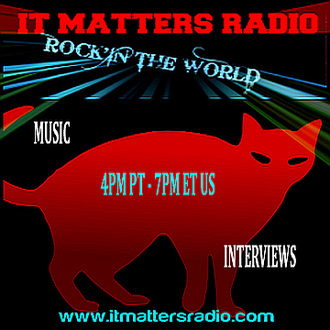

REQUIRED INFO TO SET UP INTERVIEW

- NAME OF BAND – SINGER
_______________________________________________________

- SKYPE HANDLE-NAME (You may choose to invite Monica. If so, her Skype handle is live: radmmb

_________________________________________________________

- YOUR LOCATION. WHERE YOU WILL BE AT TIME OF INTERVIEW. CITY, STATE, COUNTRY

_______________________________________________________

- LINKS TO YOU TUBE VIDEOS OR DOWNLOADS OF MP3’S-MP4’S * Note: Do not send us links to sites such as Spotify, I-Tunes or web sites where we must purchase your music. You may use sites such as We Transfer or Dropbox to send your zipped MP3 or MP4 files. You may also attach them to your e-mail to us. We require a minimum of three songs and a maximum of four.

- LINKS TO SOCIAL MEDIA YOU WISH SHARED (Facebook, Twitter, etc.)

________________________________________________________
_________________________________________________________
_________________________________________________________

- A BRIEF BIO OR WHERE WE MAY FIND YOUR INFORMATION

- LINK(S) TO WEB SITE

____________________________________________________________

Before we can hold an interview, we must have the information above sent to us. This is very important, for without the information, an interview and stream of your interview is not possible. Please send information to mbrinkman@itmattersradio.com
It is very important that once you submit the information and confirm a date for your interview, you attend the interview. We realize emergencies pop up, and if this should happen, contact us. Just know that when you confirm an interview date, it is firm. We tape the interviews in advance and will let you know the live stream date as soon as it is set up. This is between one to three weeks after taping via Skype that the show will air.
It is most effective if you share the live-stream of your interview with others, and later, the podcast of your interview. All live streams will be broadcasted via http://vaughnlive.tv/itmattersradio or from our web site @ https://www.itmattersradio.com/watch-broadcasts

We tape the interviews on Skype Video chat, then air them later as a Musical Guest Interview broadcast. After the live broadcast, your show is then placed as a podcast in our YouTube channel under the Musical Guest Interview playlist. Feel free to use the podcast for marketing or just to share.
https://www.youtube.com/playlist?list=PL7nztxPtknQ6Oai0Yq7PKYnYBJUB4kEf1

We look forward to chatting with you and sharing your talent via our broadcast and later, via our You Tube Playlist.
Monica M. Brinkman, Producer/Music Host

